Table of Contents
1. Background 3
2. Processing 4
2.1 Directory Structure and Data Ingestion 4
2.2 Data Scale and Temporal Evolution 5
2.3 Data Integration and Join Strategy 6
2.4 Analysis Based on the Enriched Stations Table 8
3. Analysis 9
3.1 Station-Level Questions 9
3.2 Daily-Level Questions 11
4. Visualizations 12
4.1 New Zealand Temperature Time Series and Data Quality 12
4.2 Global Rainfall Statistics and Extreme Value Analysis 14
4.3 Global Distribution of Annual Rainfall 14
5. Conclusions 15
6. References 16

List of Figures
Figure 1 Directory Tree 4
Figure 2 Compressed size of GHCN daily files 6
Figure 3 New Zealand stations map 10
Figure 4 New Zealand Temperature Time Series 13
Figure 5 New Zealand National Average Temperature 13
Figure 6 Global Average Daily Rainfall in 2025(mm) 15

List of Tables
Table 1 GHCN dataset sizes and formats 5
Table 2 Data schema of the enriched stations dataset 7
Table 3 Summary of Station Counts 10
Table 4 Core Element Observation Counts 12

1. Background

Working with data is really important these days. We need it to solve the problems we face every day and to understand what might happen in the future. This project was all about getting familiar with the huge GHCN‑Daily weather dataset and following the steps of analysis and visualization. It has weather records from all around the world that go back many decades. The main goal was hands-on practice. I learned to process distributed data across clusters, clean up messy entries, integrate different station files, and then do time-series analysis plus geospatial analysis. Moreover, this assignment taught me how to use PySpark to handle big scale data efficiently in a cloud environment. It also showed me how to process data much faster than standard tools like Pandas, which always crashes on my laptop with big CSV files, or even SQL queries that take forever.

This assignment uses the Global Historical Climatology Network (GHCN) which is one of the largest climate datasets used around the world. GHCN has daily weather observations from stations all over the globe with records dating back to the mid-18th century up to today. It tracks five main climate measurements, including precipitation, snowfall, snow depth, maximum temperature, and minimum temperature. Some stations also record additional variables like wind speed or sunlight hours. The dataset is split into two main parts which are daily observations and metadata files. Daily data are compressed files for each year, while metadata tables such as stations, countries, states, and inventory are stored as fixed-width text files.

GHCN data is great for studying global climate but it has some big challenges. For example, the data comes from many countries over different time periods so formats vary. The stations also have different active years and there are many missing values, which makes time series hard to align. Moreover, the daily files are about 13 GB compressed, but over 100 GB uncompressed. This is why we need tools like Spark for efficient processing.

To overcome these challenges, Spark distributes the workload across multiple executors in the cloud. It is efficient because of its lazy evaluation. It helps to get results when I do something like run a query and it works well with really large datasets. Also Spark can read files that are compressed which is really helpful. I did not have to unzip 13 GB of data that would take up over 100 GB on my laptop. PySpark also has some tools, like join, groupBy and aggregation. These tools make it much easier to organize my data.

2. Processing

In this processing section, I want to really understand how the GHCN dataset is structured and set up the code needed to load, clean, and combine all the data files. Before doing analysis and charts later, I'll check how big everything is, figure out the best way to join huge tables without crashing, and create one main table. This section shows the steps I took to answer the basic questions and describes my final enriched stations table.

2.1 Directory Structure and Data Ingestion

Figure 1 shows the ghcnd directory has four fixed-width metadata files and a daily folder with 265 yearly .csv.gz files, which total around 13 GB. Each year is a separate compressed file. Spark can load the whole directory at once, making the data ingestion process highly efficient.

The raw metadata files are stored as uncompressed fixed-width text, which requires precise character-position parsing. I set up schemas to change coordinates such as LATITUDE, LONGITUDE and ELEVATION to Double for accurate numbers and columns like ID, STATE, NAME, GSN_FLAG, HCN_CRN_FLAG, WMO_ID, country_code and country_name to StringType. For daily data, I kept a simple schema to handle all those massive records. GHCN dates don't match Spark's format. The DATE column is YYYYMMDD, but Spark expects yyyy-MM-dd. Using DateType makes all DATE values become null. To avoid this problem, I used StringType for both DATE and OBSERVATION TIME columns to ensure the massive volume of records could be processed without data loss or performance bottlenecks.

Figure 1
Directory Tree

2.2 Data Scale and Temporal Evolution
After successfully loading the GHCN directory, we can discuss file sizes. As shown in Table 1 daily files are compressed, with an estimated uncompressed size over 100GB with 3176126412 rows. Metadata includes inventory (33.7MB with 769,349 rows), stations (11.1MB with 129,657 rows), countries (3.6KB with 219 rows), and states (1KB with 74 rows).

Data size is something we need to think about because big sets of data can cause problems. They can make our computer run out of memory and take a time, to process. For example, my laptop only has 256 GB of storage. That is not enough for files, like ones that are 100 GB. When I try to work with these files on my laptop it takes a time. Everything slows down. Data size is also important when we are moving data around between steps. This can be expensive and cause problems so we want to avoid it.

Figure 2 shows the changes in daily data size from 1750 to 2026. The dataset includes 277 years but only 265 files exist because some early years are missing or combined. Early years (1750-1800) are tiny at ~1-10KB, likely due to few stations and incomplete records. The 1750 file is 1.3MB, possibly combining multiple years. The 19th century, which is from 1800 to 1900 starts small around a kilobyte. Grows to several megabytes. In the 20th century, which is from 1900 to 1950 the size really takes off going from 10 megabytes to 100 megabytes. This rapid growth is likely due to the increasing number of weather stations and more consistent recording of daily observations during this period. Nowadays files from 1950 to 2026 have reached a peak of 170 megabytes. Lately they have been around 150 to 170 megabytes. However, the data, for 2026 is not complete. Its only 21 megabytes.

Table 1
GHCN dataset sizes and formats
Dataset Name | Storage Format | Size on Disk | Estimated Uncompressed Size | Comment (Comparison to daily)
daily | .csv.gz | ~13 GB total | 100+ GB | The baseline dataset; orders of magnitude larger than all metadata files and too large for a single node’s memory.
inventory | Fixed-width text | 33.7 MB | 33.7 MB | Small compared to daily; around one to two orders of magnitude smaller.
stations | Fixed-width text | 11.1 MB | 11.1 MB | Very small relative to daily; roughly two to three orders of magnitude smaller.
countries | Fixed-width text | 3.6 KB | 3.6 KB | Negligible compared to daily; effectively zero memory footprint in comparison.
states | Fixed-width text | 1 KB | 1 KB | Negligible compared to daily; minimal footprint.

Figure 2
Compressed size of GHCN daily files
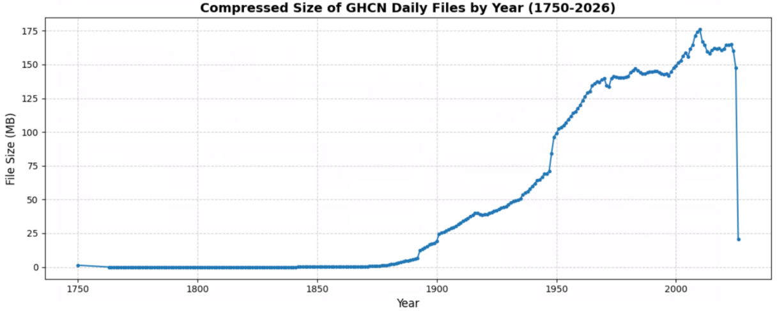

2.3 Data Integration and Join Strategy

In order to make following analysis easier, I try to merge the metadata tables into a single enriched table. The full schema of the enriched table with all columns and their descriptions, is provided in Table 2 Since several tables share the same column names, I used select function to keep only the necessary columns and applied alias function to rename overlapping columns. This avoids naming conflicts and keeps the final schema clean and readable. The metadata tables are small, so left joins are inexpensive and do not create noticeable overhead.

The daily table is the largest dataset in the assignment. Joining any table with data in Spark can cause a lot of data movement across the cluster. This movement is costly as it increases memory usage, network traffic and execution time. To minimize these costs we should be careful when joining tables with the data. One way to avoid costs is to use a Broadcast Join. This approach reduces the amount of data that needs to be moved. After combining the metadata and preparing the enriched table, the rest of the analysis can be done directly from it. However, the daily table is still the largest and most expensive part of the dataset, so using it efficiently is really important.
Table 2
Data schema of the enriched stations dataset
Column Name | Data Type | Nullable | Description
ID | String | TRUE | Unique station identifier (11 characters).
LATITUDE | Double | TRUE | Station latitude in decimal degrees.
LONGITUDE | Double | TRUE | Station longitude in decimal degrees.
ELEVATION | Double | TRUE | Station elevation in meters.
STATE | String | TRUE | 2-character state/province code.
NAME | String | TRUE | Full name of the weather station.
GSN_FLAG | String | TRUE | GSN network indicator (if applicable).
HCN_CRN_FLAG | String | TRUE | HCN or CRN network indicators.
WMO_ID | String | TRUE | WMO station identifier.
country_code | String | TRUE | 2-character FIPS country code (Derived).
country_name | String | TRUE | Full country name (Joined from countries.txt).
state_name | String | TRUE | Full state name (Joined from states.txt).
elements | Array<String> | TRUE | List of all recorded climatic elements.
core_count | Integer | TRUE | Count of core elements (TMAX, TMIN, PRCP, SNOW, SNWD).
other_count | Integer | TRUE | Count of all other recorded elements.

2.4 Analysis Based on the Enriched Stations Table

With the enriched stations table prepared, we can now use this unified structure to answer specific questions about the dataset and verify data consistency.

To identify countries with state codes. I merged stations, countries and state three tables. After that using filter function to keep the stations which really existing state. Combining select, distinct and orderBy function to keep the necessary columns and drop the duplicate columns. The output shows that only a limited set of countries and territories include state codes in the GHCN metadata. These include the United States and its associated territories such as Northern Mariana Islands, Guam, Johnston Atoll, Palmyra Atoll, Virgin Islands and Wake Island. While Canada and Bahamas also have state code.

After identifying the countries with state codes, I examined station activity using the inventory table. For each station, I checked the first and last year it recorded observations. A station is considered active in 2026 if its active period covers that year. Based on this, there are 30963 stations still active in 2026, which gives a sense of how large the current observing network is in the dataset.

To examine element coverage, I first grouped all recorded elements for each station using collect_set so that each station’s elements were evaluated as a single set rather than individual rows. Following, I compared these sets with the five core climatic elements. Based on this comparison, 20508 stations collected all five core elements, while 16137 stations recorded only precipitation (PRCP). I initially tried filtering rows directly by element type, but that counted the number of observations instead of the number of stations, so using element sets provided the correct station‑level counts.

To check consistency between the stations metadata and the daily dataset, I compared station IDs in the enriched table with the distinct IDs from the 2026 daily records. I used a left_anti join to find stations that appear in the metadata but not in daily. The result shows that 97247 stations in the stations table do not have any matching daily observations. I also did the reverse check by comparing the distinct 2026 daily station IDs against the metadata, and the result was 0, which means every station in the 2026 daily data is listed in the metadata.

3. Analysis

In this section, I separate the analysis into station‑level questions and daily‑level questions. For each item, I first report the result and then briefly explain how I obtained it using Spark. I also include short reasoning when it helps clarify why I chose a particular method.

3.1 Station-Level Questions

This part focuses on analyzing the enriched table. Table 3 illustrates that there are 129657 stations around the world. By combining filter and count function, I extracted the stations that belong to the GSN, USHCN, USCRN, and multi‑network categories. The results show that 991 stations are part of the GSN network, 1218 belong to USHCN, and 234 belong to USCRN. In addition, 15 stations appear in more than one network.

Mapping the locations helps show exactly where all these stations are. By filtering stations with a latitude below zero, I found that 25357 stations are located in the Southern Hemisphere. Among them, 15 stations are in New Zealand, and their exact locations are shown in Figure 3 After checking the Southern Hemisphere, I moved on to finding the stations in U.S. territories. While looking through the country names, I noticed a pattern with these stations always have “[United States]” added to the end of their name." However, after inspecting all values, I found that the entry for “Midway Islands” ends with “}” instead of “]”. Because of this inconsistency, filtering only for “[United States]” would miss one station, leading to an undercount. To address this issue, I applied two filters. First, I filtered the country_name column using contains ("United States") to successfully capture all U.S. territories. To make sure I didn't accidentally count the mainland, I added one more filter to remove exact matches for “United States”. That gave me the final number with 414 stations in the territories.

To find the closest pair of stations in New Zealand. In the first step I chose to narrow down the dataset. I used filter function to keep only the row in the enriched table where the country_name column is New Zealand. I also selected the ID, latitude, and longitude columns because I needed to compute distances by using them. After that, I used a cross join so that every station was paired with every other station, which allowed me to calculate the distance for all possible pairs. Because the Earth is curved. As a result, I used the Haversine UDF to compute the distance between each pair of stations. The Haversine formula converts latitude and longitude into radians and computes the great‑circle distance on a sphere, which properly accounts for the curvature of the Earth by using its mean radius of approximately 6371 km. This method is widely used in geospatial analysis and provides acceptable accuracy for global‑scale distance calculations ("Haversine formula," 2026). After calculating all the distances, I removed the pairs where both station IDs were the same and kept only the cases where a.ID < b.ID so each pair showed up once. Finally, I sorted the results by distance to find the absolute minimum. The closest pair of stations in New Zealand turned out to be NZ000093417 and NZM00093439. The distance between them roughly 50.53 km apart. I also saved the complete table of all pairwise distances to my output directory for future reference.
Table 3
Summary of Station Counts
Category | Count | Description / Methodology
Total Stations | 129657 | The absolute total of unique stations in the dataset.
GSN Stations | 991 | Stations belonging to the GCOS Surface Network.
USHCN Stations | 1218 | Stations in the U.S. Historical Climatology Network.
USCRN Stations | 234 | Stations in the U.S. Climate Reference Network.
Multi-Network Stations | 15 | Stations cross-listed in more than one specialized network.
Southern Hemisphere | 25357 | Stations located south of the equator (Latitude < 0).
U.S. Territory Stations | 414 | Stations in territories like Guam and Midway, excluding the US.
New Zealand Stations | 15 | Total monitoring sites identified within New Zealand.
Active Stations (2026) | 32410 | Stations with actual observations recorded in the daily data.

Figure 3
New Zealand stations map
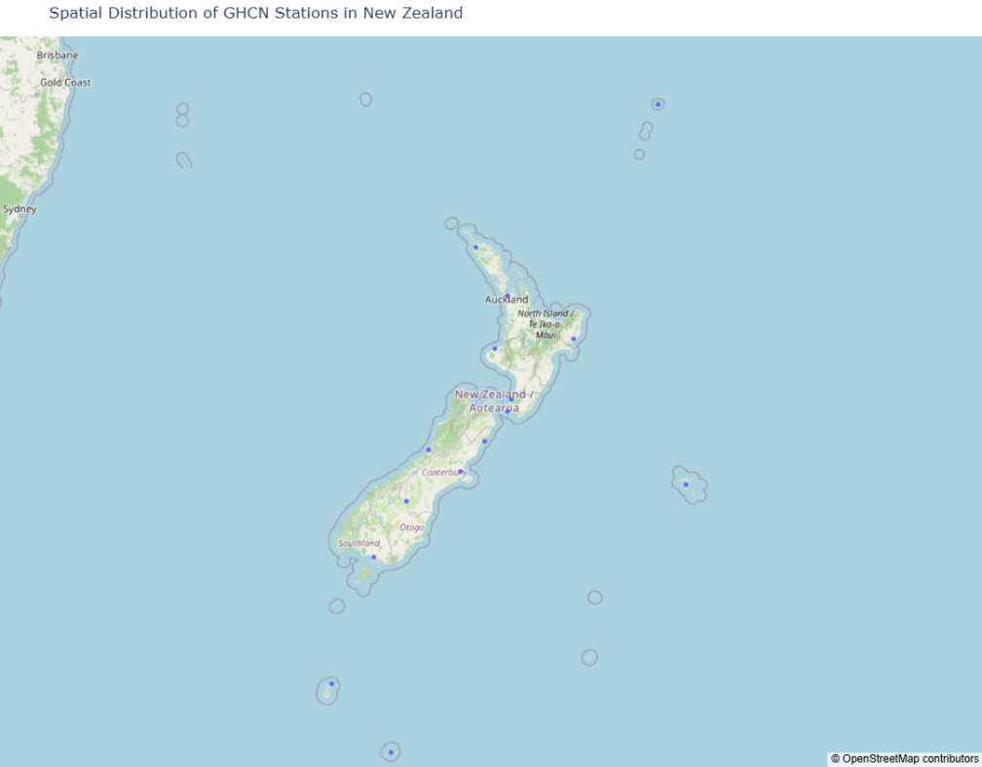

3.2 Daily-Level Questions

After completing the station‑level analysis, I turned my attention to the daily dataset. There is a large amount of information in the daily dataset. To see which stations are still working in 2026, I used only the 2026 daily file, because the daily data is stored as a separate file for each year. By combining select ID, distinct function, and count function, I found that 32410 stations are still active in 2026. Interestingly, this is higher than the 30963 active stations I calculated from the inventory metadata earlier. This proves that the official metadata isn't perfectly synced up with the latest daily records. I was also curious about the total size of the full daily dataset. After loading the entire daily directory, I found that it contains 3176126412 rows in total. This confirms that the daily dataset is extremely large and requires distributed processing to handle efficiently.

In addition, I also examined how many observations exist for each of the five core elements. To do this, I first defined the list of core elements (PRCP, SNOW, SNWD, TMAX, and TMIN). I then filtered the 2026 daily dataset to keep only rows where the element column matches one of these values. After filtering, I grouped the data by element and applied the count function to compute the number of observations for each element. The results are summarized in Table 4 Among the five core elements, PRCP has the most observations, with 1378425 records. SNOW is the second most common element, with 835598 observations, followed by TMIN with 567721 and TMAX with 567501. SNWD has the fewest observations, with 439584 records. This pattern makes sense because precipitation and temperature are recorded at most stations, while elements related to snow only appear in places where it actually snows.

To check how often TMAX and TMIN are not both recorded on the same day for the same station, I first filtered the 2026 daily dataset into two separate tables: one with only TMIN observations and one with only TMAX observations. For both tables, I use select function to keep only the station ID, date, and value columns, since the matching is based on the same station and the same date. To find TMAX observations that do not have a matching TMIN value, I used a left_anti join between the TMAX and TMIN tables on ID and date. A left_anti join returns only the TMAX rows that do not have a match in TMIN. This is a good choice for large datasets because it works more efficiently. Using this method, I found that 1771 TMAX observations do not have a matching TMIN observation in 2026. I also counted how many unique stations were involved by taking the station IDs from the unmatched rows, using distinct function and then counting them. In total, 658 unique stations had at least one missing TMIN value. This shows that the missing observations are spread across many stations.

Table 4
Core Element Observation Counts
Element | Count
SNWD | 439584
SNOW | 835598
TMIN | 567721
PRCP | 1378425
TMAX | 567501

4. Visualizations

In this section, I use several visualizations to look at both data quality and long-term climate patterns in the dataset. I start by checking New Zealand’s time series and data completeness, then move on to global rainfall statistics and spatial patterns.

4.1 New Zealand Temperature Time Series and Data Quality

Before diving into New Zealand's temperature trends, I needed to figure out our timeline. I pulled the year from the date column, cast it to an integer and checked the overall range. It turns out there are 87 years of data, running from 1940 right up to 2026. More details can be seen in Figure 4 and Figure 5.

To check whether New Zealand has any missing years in its time series, I first extracted the year from each observation and created a list of all distinct years that actually appear in the dataset. By comparing this list with the full expected range of years between the minimum and the maximum year. If every year in this range shows up at least once, then there are no gaps at the national level. The result shows that there are no missing years in New Zealand’s time series. However, the New Zealand stations plot in Figure 4 clearly shows several discontinuities. This happens because the national dataset has no missing years, but individual stations do not report continuously.

Because these gaps in station correspond to real periods with no measurements, I did not fill the missing years. Keeping them as they are avoids creating artificial trends and better preserves the original data. I also did not use daily temperature values directly, because they contain a lot of short term weather noise that hides long‑term climate patterns. Instead, I used yearly smoothing by averaging TMIN and TMAX within each year, which makes the long term temperature trends much easier to see.

Figure 4
New Zealand Temperature Time Series
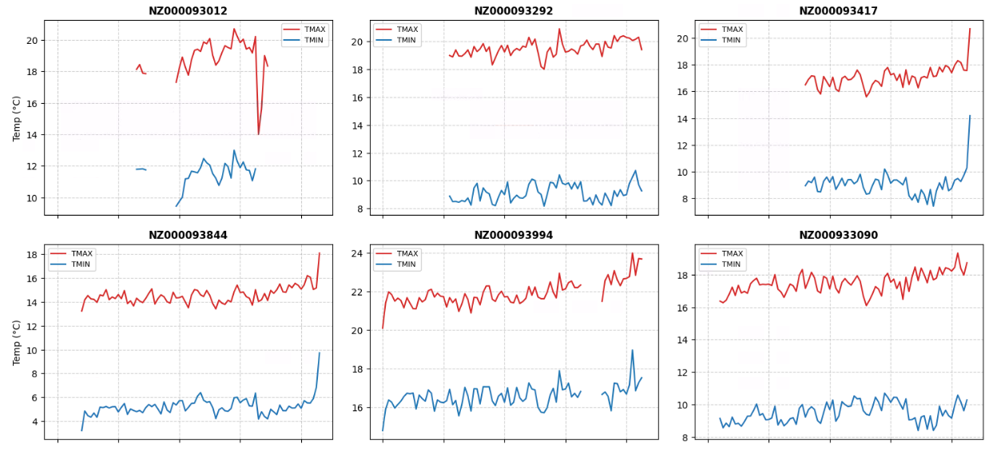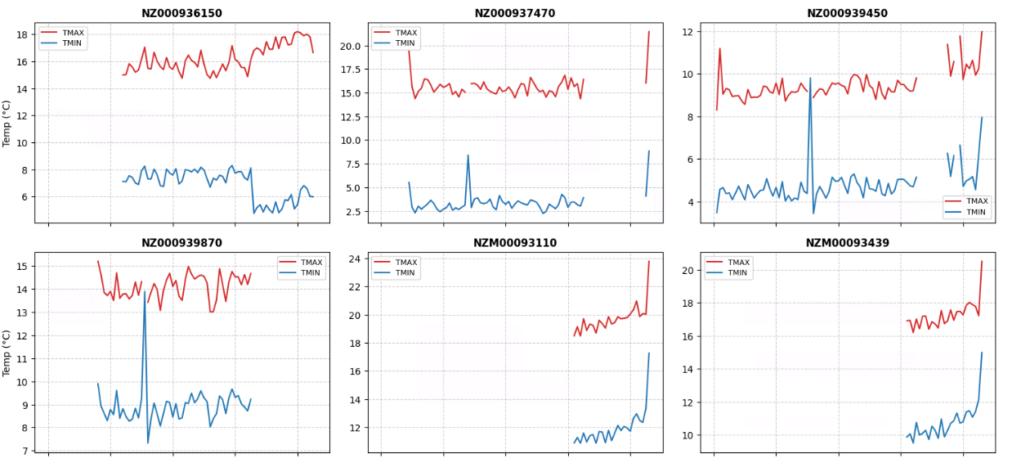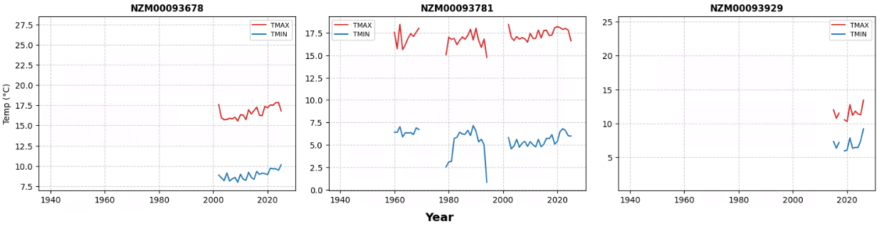
Figure 5
New Zealand National Average Temperature
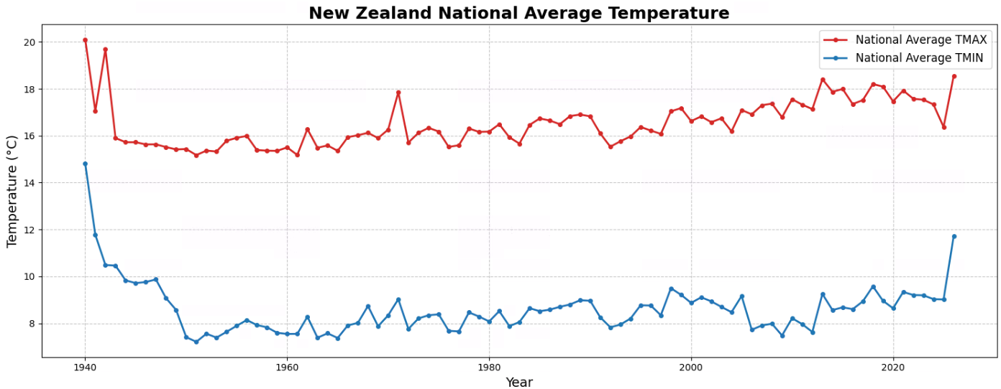

4.2 Global Rainfall Statistics and Extreme Value Analysis

To map out global precipitation patterns, I stripped the dataset down to only the PRCP observations. I then extracted the year and country codes, converted the values to millimeters, and computed the average daily rainfall for each nation. This two stage aggregation, which first groups the data by country and year and then summarizes across all years for each country, produced 17784 averages. The descriptive statistics show that the global distribution of annual average rainfall has a mean of 4.19 mm/day and a standard deviation of 8.41 mm/day, with values ranging from −0.108 mm/day to 436.1 mm/day. It is interesting that the minimum value can be zero but cannot be a negative number, which means there are wrong data in these records. The averages are more stable in countries with many reporting stations. On the flip side, countries with only a handful of stations show way more variance. It makes sense. Without enough data points, it is easier for an outlier to affect the result. A single extreme weather event can easily pull the whole national average up or down.

When checking the results, one number immediately jumped out. Equatorial Guinea (EK) showed a massive 436.1 mm/day in 2000. This is probably not a real national average. It’s almost certainly a sensor glitch or the result of having too few stations, where one bad reading completely throws off the mean. If I was to map this data directly, that one massive outlier would completely mess up the colors and make the rest of the world look empty. This really shows why it's so important to clean out weird numbers using methods like IQR or Z-scores before making any maps ("Outlier," 2026).

4.3 Global Distribution of Annual Rainfall

Figure 6 visualizes the 2025 average daily rainfall. To put this together, I extracted the two letter country code from the station ID so I could join the rainfall data with the enriched table for the full names. Since the enriched table is pretty small, applying a broadcast join kept the whole process highly efficient. Before plotting, I made sure to remove any duplicates so each country only gets colored in once.

Since I had already grouped the rainfall data by country, going with a choropleth map was the most natural choice. It is the easiest way to see the wettest and driest places at a glance. By shading each country according to its average rainfall. Figure 6 clearly shows wet and dry regions around the world and makes unusually high or low values easy to spot. Looking at the map, the climate differences are super obvious. Places near the equator, like Angola, clearly stand out with heavy rainfall. On the flip side, countries way up north like Canada show up as much drier. For the colors, countries with high rainfall are shaded dark blue, leaving the drier ones in light blue. Some countries look unusually dark because of extreme values in the rainfall data, so the map also helps show these unusual points.

A few countries ended up missing from the final map. This is just a mismatch issue. If a country's name doesn't line up with Plotly's underlying Natural Earth dataset, the library can't draw its boundaries. For the overall style, I picked the Natural Earth projection over Mercator. It shows a much more realistic global shape, making it a way better fit for climate-related visualizations (Natural Earth, n.d.).

Figure 6
Global Average Daily Rainfall in 2025(mm)
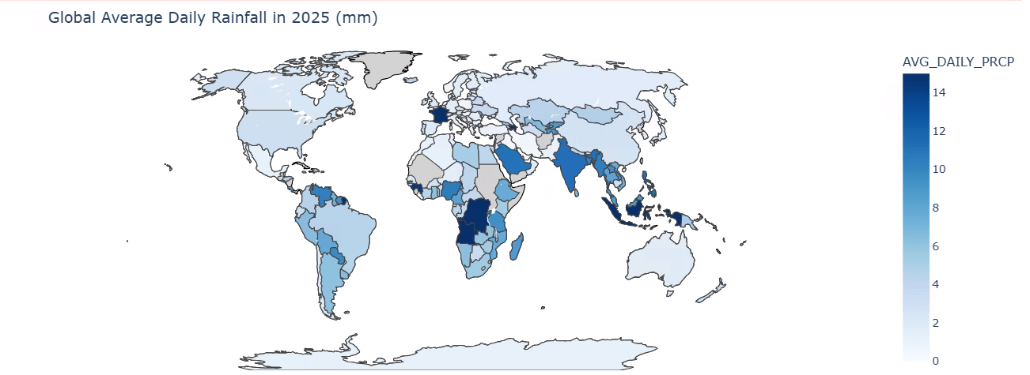

5. Conclusions

Overall, this assignment showed me how to work with massive climate data from start to finish. I learned to clean messy observations, join different metadata tables, and analyse long‑term patterns using Spark. Most importantly, my learning journey involved getting comfortable with many PySpark tools and turning chaotic raw data into meaningful information.

During the analysis phase, I learned how to combine functions like count and filter to calculate station distributions around the world. I also used groupBy to check station numbers, and one of the biggest milestones for me was learning how to write PySpark UDFs (User‑Defined Functions). For example, I wrote a Haversine function to calculate distances between stations in New Zealand. Using functions like select, distinct, and join also taught me how to quickly find active stations and deal with missing values more efficiently.

My learning process continued into the visualization stage. I learned how to use substring to extract years and how to average TMAX and TMIN to smooth out daily noise. I also learned to use pivot to line up all stations on the same timeline, which naturally showed missing years as gaps. This helped me plot individual subplots and national line charts to clearly compare New Zealand’s long‑term temperature trends. Finally, I learned how to join the 2025 precipitation data with country names to create a global choropleth map, which made it easy to see the differences between countries.

Putting Spark’s powerful data processing together with good visual analysis helped me turn raw data into real climate insights. This hands‑on experience has made me much more confident in handling big data projects from start to finish.

6. References
I used Gemini as a supporting tool for this project. Specifically, the AI helped me brainstorm the logic for the Haversine UDF, assisted in debugging PySpark code errors, and provided suggestions for correcting the English grammar and sentence flow in the final write-up.

Haversine formula. (2026, March 13). In Wikipedia. https://en.wikipedia.org/w/index.php?title=Haversine_formula&oldid=1343219764
Natural Earth. (n.d.). Natural Earth: Free vector and raster map data. https://www.naturalearthdata.com/
Outlier. (2026, March 21). In Wikipedia. https://en.wikipedia.org/w/index.php?title=Outlier&oldid=1344680531

